ASSIGNMENT NO.3

Activity 1: Filtering Data using WHERE

1.1 Find students older than 21
SELECT * FROM Student
WHERE Age > 21;
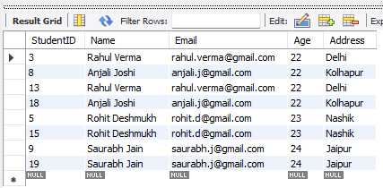

1.2 Students whose age is between 18 and 22
SELECT * FROM Student
WHERE Age BETWEEN 18 AND 22;
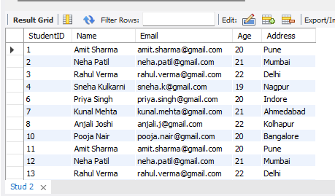

Activity 2: Sorting Results using ORDER BY

2.1 Students sorted by name
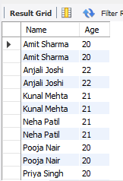
SELECT Name, Age
FROM Student
ORDER BY Name ASC;

2.2 Students sorted by age descending
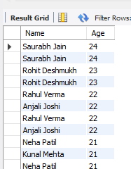
SELECT Name, Age
FROM Student
ORDER BY Age DESC;

Activity 3: Aggregation using GROUP BY

3.1 Total number of students
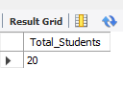
SELECT COUNT(*) AS Total_Students
FROM Student;

3.2 Average age of students
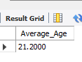
SELECT AVG(Age) AS Average_Age
FROM Student;

Activity 4: Multi-table Queries using JOIN

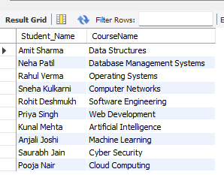
4.1 Student names with course names
SELECT s.Name AS Student_Name, c.CourseName
FROM Student s
JOIN Enrollment e ON s.StudentID = e.StudentID
JOIN Course c ON e.CourseID = c.CourseID;

4.2 Course names with instructor names
SELECT c.CourseName, i.Name AS Instructor_Name
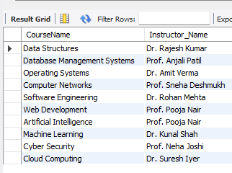
FROM Course c
JOIN Instructor i ON c.InstructorID = i.InstructorID;

Activity 5: Nested Subqueries

5.1 Students enrolled in 'DBMS' course
SELECT Name
FROM Student
WHERE StudentID IN (
SELECT StudentID
FROM Enrollment
WHERE CourseID = (SELECT CourseID
FROM Course
WHERE CourseName = 'Data structures'
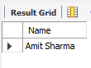
)
);

5.2 Student(s) with highest age
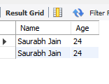
SELECT Name, Age
FROM Student
WHERE Age = (SELECT MAX(Age) FROM Student);

